Building Strong Faith - Lessons from Haggai
Lesson 3: Innovate
Notes to accompany teaching or as stand alone
Welcome – What gadget or app have you discovered or appreciated most during the pandemic?
Word - Read Haggai 1 :12-15
As we step out in obeying God’s commands his promise is that he will be with us?
When else is scripture does God promise to be with us when we obey him? What command came with this promise?
How have you experienced ‘God with you’? What does it look/feel like?
What is stopping you knowing or experiencing God’s presence today?
How are you obeying the great commission (Matthew 28:19&20)
In obeying fully the people needed to be INNOVATIVE. They were being innovative at home (panelled houses) and now needed to be innovative in building the kingdom of God. The trees had been destroyed by Nebuchadnezzar when he captured Jerusalem so they now needed to innovate in getting wood from the mountains (v8).
We need to innovate today, in a pandemic, to still build the church and obey the great commission?
In what ways as a church have we been innovative? How have these helped us obey the great commission?
What other ways can we be innovative to help us obey the great commission? With children, young people, neighbours….
I believe one way we need to innovate is in using the same principles we are using from the government in our homes to help us obey the great commission.
- Begin with your own household. What does it mean for you to share the gospel and teach the commands in your household?
- Discover 6 Christians or households to encourage you in following Christ
- Choose 6 to pray for and share your faith with

I came across this from the Oxford Diocese. How could following this rule of 6 help us in obeying Matthew 2819-20. In what other ways can we be innovative?
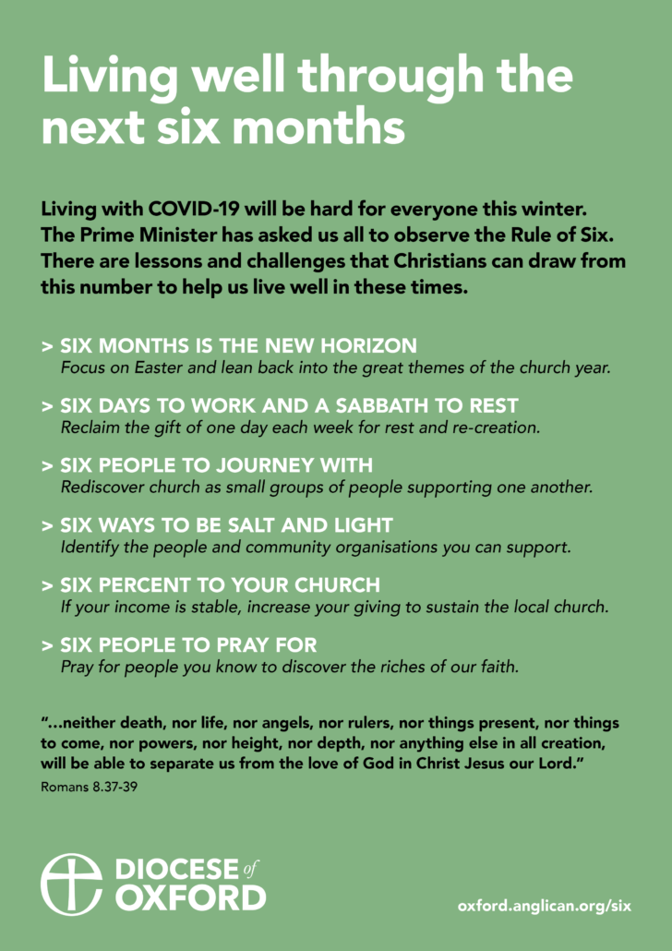

Acts 20:18-35
The bible character that best epitomises INNOVATION for me is the apostle Paul.
Use this passage and what you know about Paul to come up with ways that Paul was innovative.
Below are my suggestions – what encouragement are they for us today?
- He went to anyone who was interested – he crossed racial and social divides.
- He taught openly in the public square.
- He established churches in homes and households.
- He taught his coverts extensively to make them disciples.
- He persuaded and also demonstrated the power of the gospel.
- He worked hard and suffered for the gospel.
- He kept on reaching into new areas.
Worship
Spend some time worshipping together. Explore how you as a small group can worship together. As at this time, these groups may be the easiest place to worship. Do you have musicians? How can you explore and exercise spiritual gifts? How can you use scripture to enable your worship? What about YouTube clips? How can you use your bodies in worship?
Witness
What non-Christian family and friends do you see the Lord softening and opening up to him in these strange times? Commit to pray for them. Perhaps make a brick (cube) and write on the 6 faces – 4 people you want to bring into the household of God, top face pray for WBC and bottom face a mission organisation.

